Author: Vlad Roskov (vos)

**Added at 10:50 UTC:** there was a typo in the flag. Please re-submit.

HONEY HELP!!!

I was working in my Kali MATE, pressed something, AND EVERYTHING DISAPPEARED!

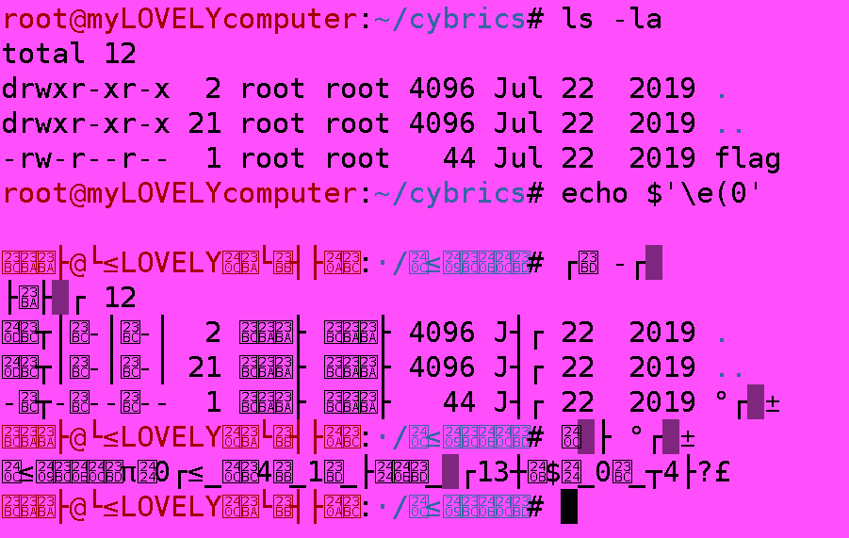

I even copied the [text from terminal](https://cybrics.net/files/honey_help.txt)